ThreatMap - Network Attack Simulation and Visualization
Submission-ready Cisco Packet Tracer report with attack-response evidence, screenshots, and validation notes.
- Tool: Cisco Packet Tracer
- Simulated attacks: DoS-style service disruption, Port Scanning, and MAC Flooding
- Primary controls: Router ACL, Port Security, and Syslog-based event evidence

Executive summary: This submission keeps the original topology and demonstrates three attack scenarios with Packet Tracer-compatible evidence. DoS is represented as hostile service-disruption traffic because true bandwidth saturation is outside Packet Tracer's model. Port Scanning is documented through blocked management-port probing, and MAC Flooding is contained with Port Security on SW-Core Fa0/2.

1. Network Topology and Device Roles
The network is segmented into an attacker zone, a protected server zone, a legitimate-client zone, and a Syslog collection node. Router-ACL is the main filtering point between 192.168.1.0/24 and 192.168.2.0/24, while SW-Core Fa0/2 is the access-layer defense point used to stop MAC flooding.
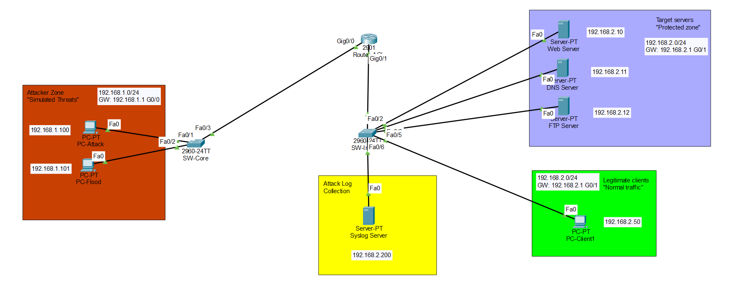
Figure 1. ThreatMap topology with explicit attack, defense, and log-collection markers.
2. IP Plan and Baseline Addressing
All devices were assigned static addresses before testing so the source of every attack and the destination of every response could be identified unambiguously.
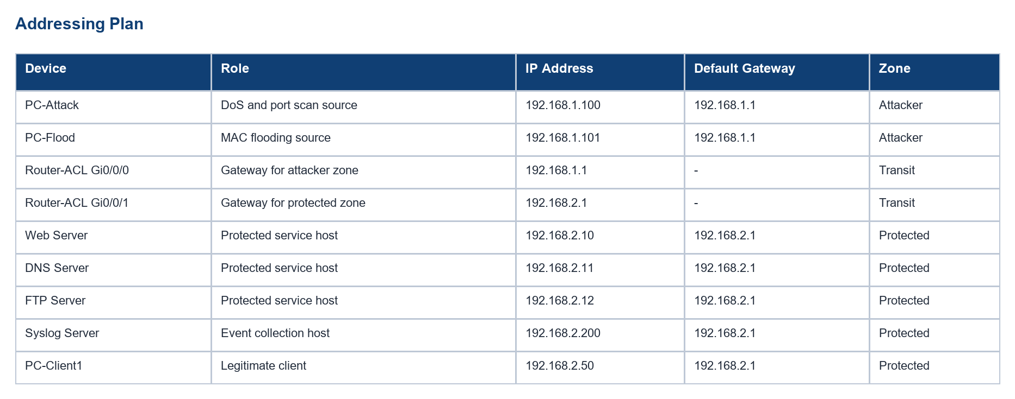
Table 1. Static addressing plan for attacker, protected, logging, and legitimate-client nodes.
3. Defensive Configuration
3.1 Router ACL policy
The router uses one extended ACL named ANTI-DOS. It blocks hostile ICMP from the attacker subnet and blocks TCP management ports 22, 23, and 3389 before the traffic reaches the protected zone.
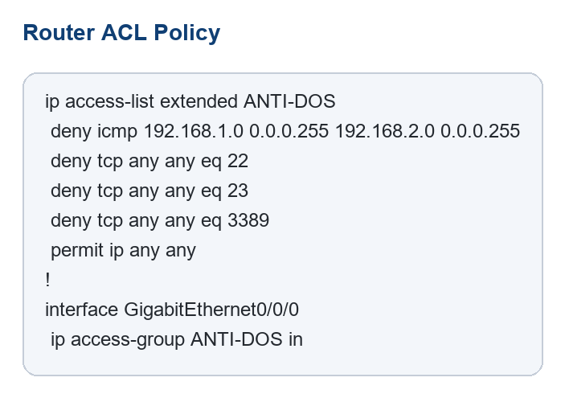
Figure 2A. ANTI-DOS ACL definition and inbound application point.

3.2 Port Security on SW-Core Fa0/2
Port Security is applied on the attacker-side access port connected to PC-Flood. The port learns a single sticky MAC address and moves to shutdown mode if an additional device or hostile MAC behavior appears.
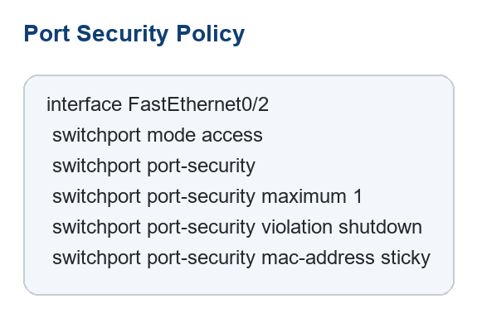
Figure 2B. Port Security policy applied to SW-Core Fa0/2.
3.3 Syslog configuration and Packet Tracer limitation
Router-ACL forwards supported system events to the Syslog Server at 192.168.2.200. Packet Tracer does not support the ACL log keyword and this router image rejects logging trap warnings, so the report uses Syslog-supported router events, ACL counters, and port-security state as the formal evidence set.
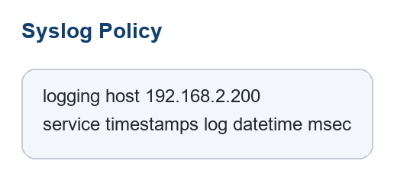
Figure 2C. Syslog destination and timestamp configuration used for supported event capture.
Packet Tracer limitation: The DoS requirement is implemented as a hostile traffic or service-disruption simulation, not a real volumetric bandwidth flood. Likewise, per-attack ACL logging is limited on this platform, so supported Syslog events plus counter-based proof are used as the documented workaround.

4. Attack-response Evidence Matrix
The following matrix maps each required attack to its source, intended impact, defensive control, observable outcome, and the proof artifact used in the submission.
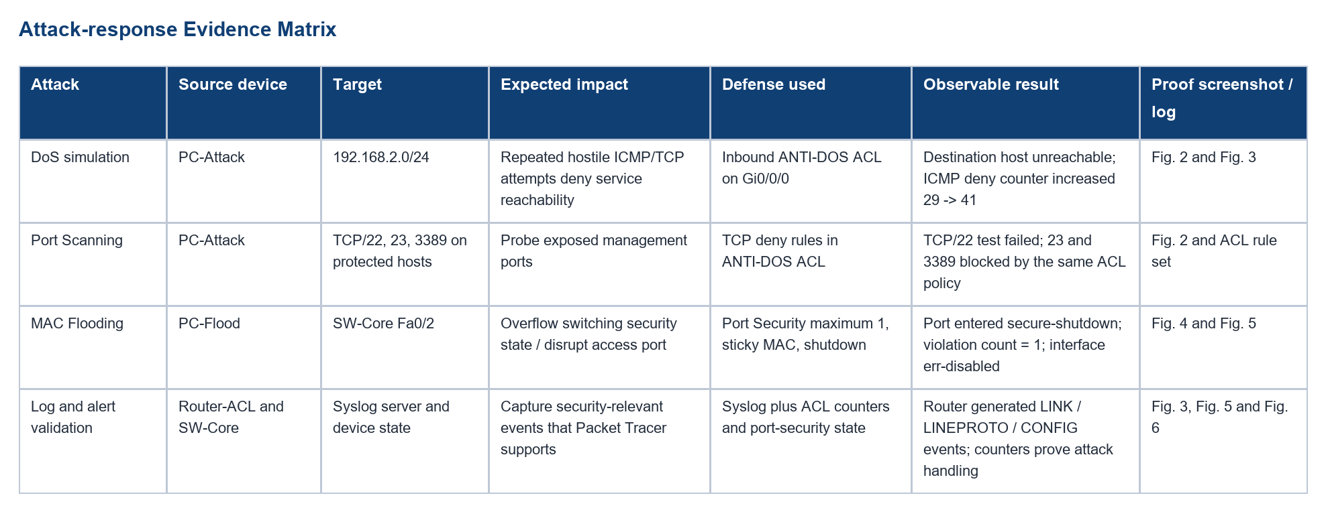
Table 2. Attack, impact, defense, and proof mapping for the full ThreatMap scenario.
5. Attack Simulation Results
5.1 DoS-style service disruption proof
PC-Attack repeatedly sends ICMP requests to the protected hosts 192.168.2.10, 192.168.2.11, and 192.168.2.12. Each attempt fails with 'Destination host unreachable' from the router gateway, which shows that the ACL stops the traffic before it reaches the protected devices.
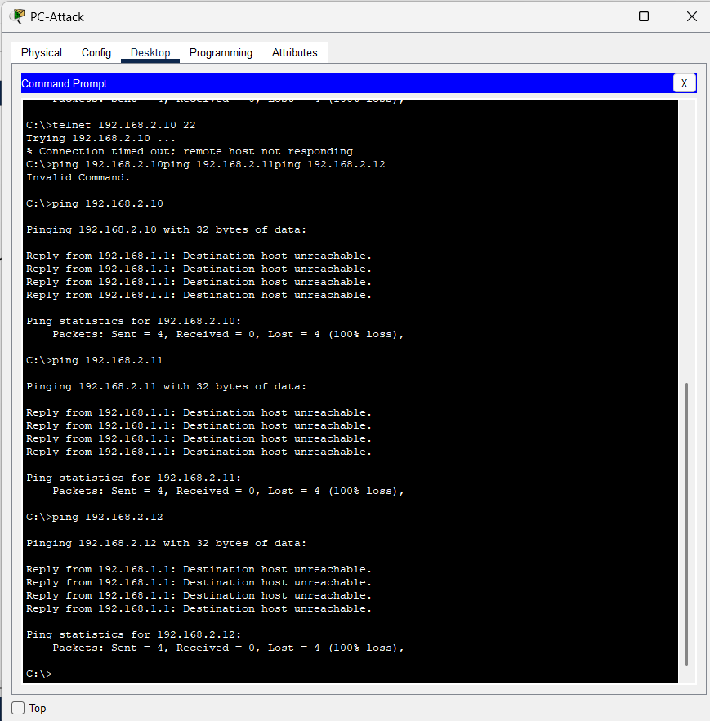
Figure 2. PC-Attack repeatedly fails to reach protected hosts during the simulated service-disruption test.
5.2 Port Scanning proof
The same attacker workstation probes administrative services on the protected subnet. In Packet Tracer, the Telnet client is used as a lightweight TCP probe; when it targets TCP/22 the blocked service under test is SSH, not Telnet. TCP/23 and TCP/3389 are blocked by the same ACL policy and are documented in the rule set and evidence matrix.
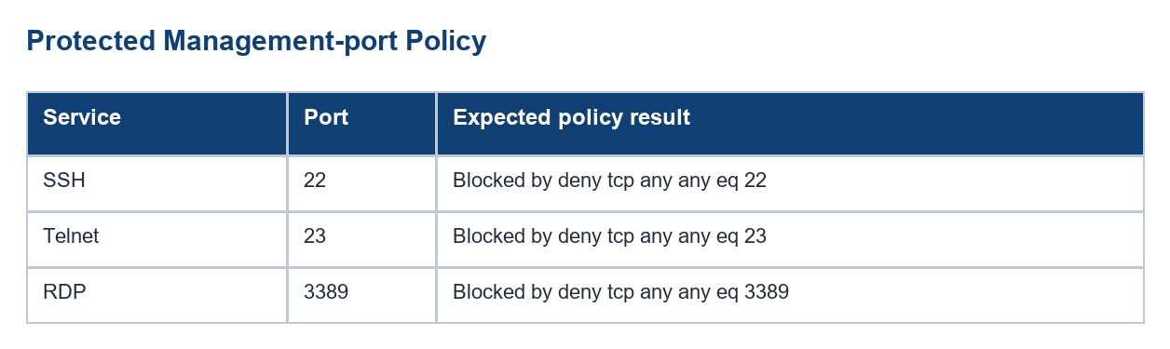
Table 3. Administrative service ports covered by the inbound ACL policy.
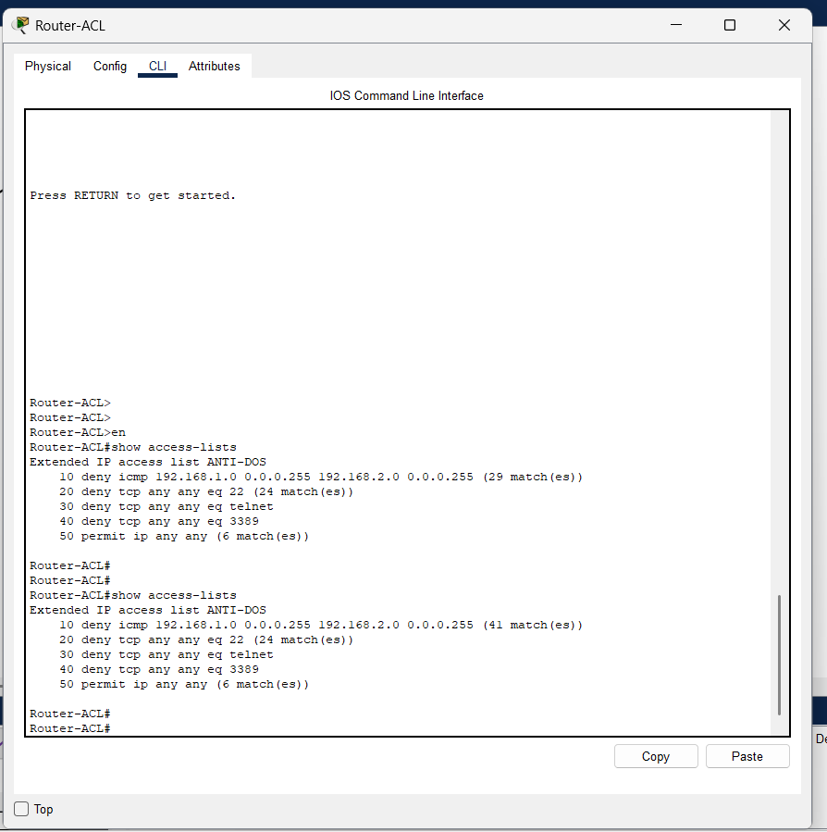
Figure 3. show access-lists verifies that the ICMP deny counter increased from 29 to 41 matches after testing.
5.3 MAC Flooding proof
Before the violation, SW-Core Fa0/2 is in secure-up state with a single sticky MAC address. After the unauthorized condition is introduced, the switch increments the violation counter, moves the port to secure-shutdown, and the interface becomes err-disabled.
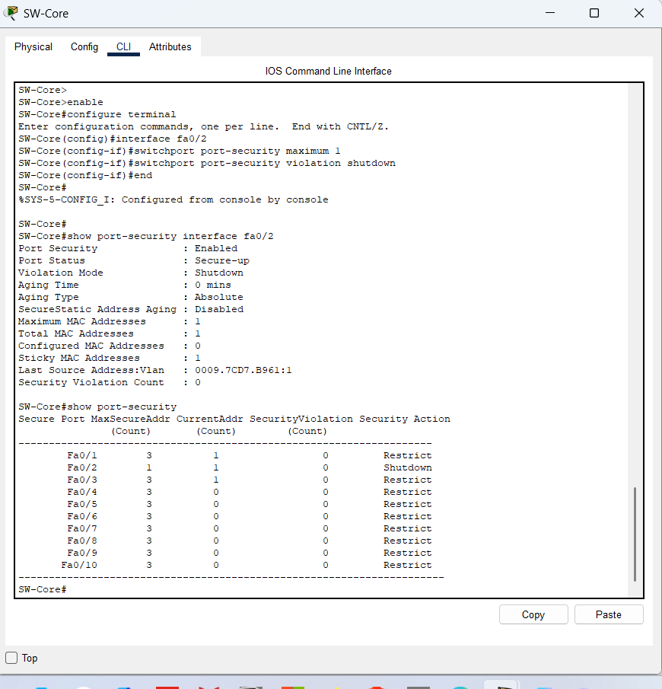
Figure 4. Baseline Port Security state on SW-Core Fa0/2 before the violation.
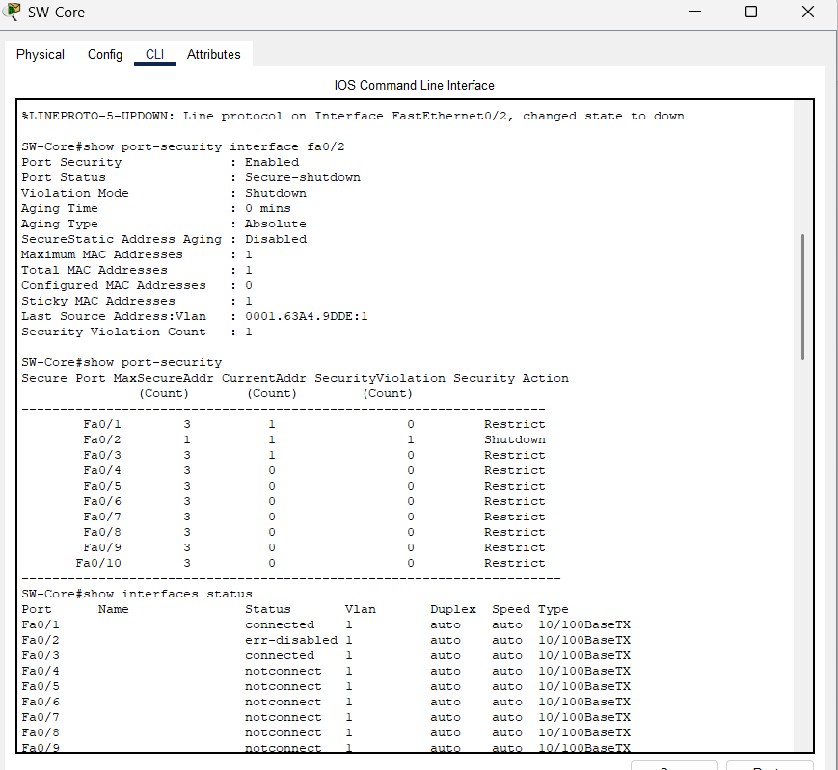
Figure 5. Port Security violation forces SW-Core Fa0/2 into secure-shutdown and err-disabled state.
5.4 Logging and alert evidence
The Syslog Server successfully records supported router events such as interface state transitions and configuration changes. These events act as the logging proof for the Packet Tracer scenario, while ACL counters and switch security counters provide the per-attack response evidence that the platform can reliably expose.
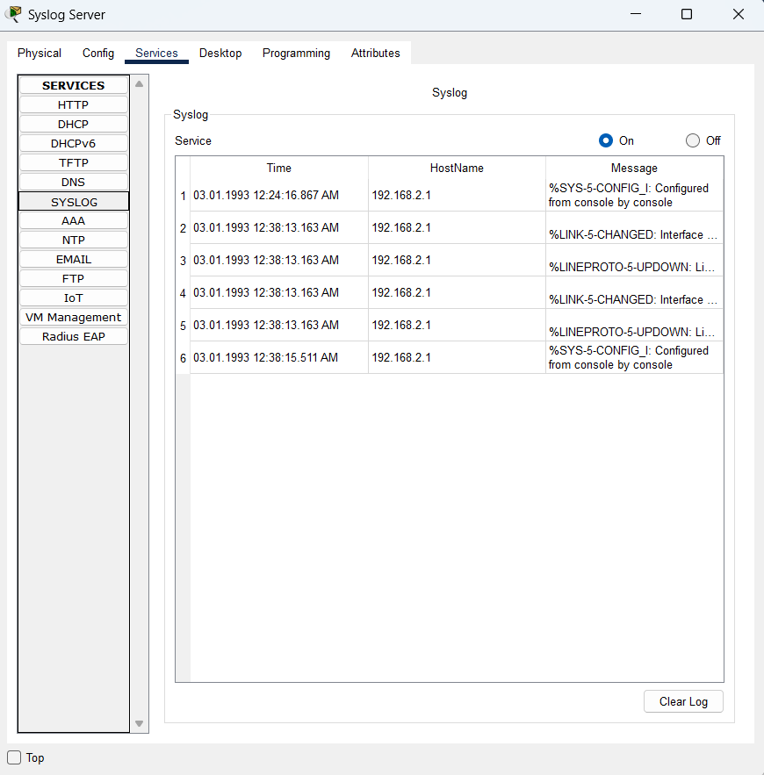
Figure 6. Syslog Server captures supported Router-ACL events used as the Packet Tracer logging workaround.
6. Final Validation
The final verification confirms that the required attacks were simulated and that the defenses responded in a measurable way. The network remains segmented, attacker traffic is blocked at the correct control point, and the security evidence is documented with screenshots, counters, and logs.
- ICMP from the attacker subnet to the protected subnet is blocked and measurable in the ACL counter.
- TCP management ports 22, 23, and 3389 are covered by explicit deny statements in ANTI-DOS.
- MAC flooding is contained at SW-Core Fa0/2 by Port Security shutdown behavior.
- Syslog receives supported events from Router-ACL and supplements the unsupported ACL log keyword.
- The final permit rule preserves normal traffic policy for legitimate flows outside the blocked conditions.

